ETFO 2019 Workplace Violence Symposium

Summary Report
December 2-3, 2019

#ETFOWVS
etfohealthandsafety.ca
Elementary Teachers' Federation of Ontario (ETFO) 136 Isabella Street, Toronto, ON M4Y 0B5
416-962-3836 or 1-888-838-3836
etfo.ca
Follow us online at:
ETFOprovincialoffice
@ETFOeducators
@ETFOeducators
Copyight © July 2020 by ETFO
Contents
ETFO 2019 Workplace Violence Symposium Summary Report 3
Introduction 3
Dr. Darcy Santor and Dr. Chris Bruckert, University of Ottawa 5
Annie Kidder, Executive Director, People for Education 9
Chris Broadbent (TDSB), Janice McCoy (OCDSB), Lee-Anne Feltham (OCETFO/FEEO) 13
Dr. Peter Smith, Institute for Work and Health 22
Christine Preece, St. Clair Catholic District School Board Schools Cannot Do It Alone 27
Appendix 1: Participating Organizations 31
Appendix 2 32
References 33

ETFO 2019 Workplace Violence Symposium
Summary Report
You are leaders. You are educators. You have power, you have privileges and you have status. There are young ones – the next generation – looking to you as an example.
Aqua Nibii Waawaaskone, Opening Ceremony to the Symposium

Introduction
This Summary Report (the “Report”) for the ETFO Workplace Violence Symposium (the “Symposium”) is an ETFO resource to support the collaborative work of making violence in schools a leading priority for action.
The ETFO Workplace Violence Symposium took place over the evening of December 2, 2019 and the day of December 3, 2019 at the Delta Hotels Toronto Airport and Conference Centre, Toronto, Ontario.
In addition to ETFO provincial and ETFO local representation, there were 46 external organizations represented at the Symposium including federal and provincial federations and unions; school board and professional associations; provincial government; workplace health and safety; children and youth mental health; and media (Appendix 1) with a total of 160 registrants.
The Symposium provided an unprecedented opportunity for diverse organizations to share their expertise about violence in school communities; to take stock of progress and barriers in prevention; and to identify the key actions needed for our schools to be safer and healthier places to learn and to work.
Symposium participants were welcomed by Aqua Nibii Waawaaskone of Aqua Music (aquamusic.ca) who acknowledged the traditional lands and performed a hand drum story and song. Aqua said, “You are leaders, you are educators. You have power, you have privileges and you have status. There are young ones – the next generation – looking to you as an example.”
ETFO President Sam Hammond welcomed the participants with opening remarks.
“Violence in schools is a crisis that continues to worsen, and we need help. To get that help, we must be stronger together. We are going to need significant, collaborative efforts and expertise, along with sustained resources and funding. From within and beyond the education sector.”
The Symposium program included five guest presenters and three expert panelists, each with a unique, professional perspective on the issue of violence in schools and the well-being of the people who work and learn in school communities. In addition, Symposium participants engaged in facilitated discussion groups to share common concerns and next steps.
This Summary Report provides highlights from each Symposium presentation, the expert panel and the discussion groups. ETFO encourages you to access the etfoheathandstafey.ca website to view the Symposium presenter PowerPoint presentations, along with additional materials from the Symposium.
Symposium participants have expressed strong interest in “what’s next?” for this shared journey. One such opportunity could be the establishment of a provincial leadership table for the prevention of violence in schools, with the mandate and the expertise to address the health, safety and well-being of everyone in the school community.
In the short-term, we need a draft framework for what is possible to address school violence, building on leading practices and finding new ways to work together. A practical first step would be a round table event, with partners including the ministries of health, labour and education.
We look forward to continuing the conversation.
The Elementary Teachers’ Federation of Ontario (ETFO) represents 83,000 elementary public school teachers, occasional teachers and education professionals across the province and is the largest teacher federation in Canada.

Dr. Darcy Santor and Dr. Chris Bruckert, University of Ottawa
Facing the Facts: The Escalating Crisis of Violence Against Elementary School Educators in Ontario
Dr. Darcy Santor is a practicing clinical psychologist and a Professor of Psychology at the University of Ottawa with expertise in student mental health. Dr. Chris Bruckert is a Professor of Criminology at the University of Ottawa with expertise in gendered violence.

Background
Dr. Santor and Dr. Bruckert spoke to some of the key messages in their 2019 report, Facing the Facts: The Escalating Crisis of Violence against Elementary School Educators in Ontario. The report reflects the outcomes of a survey that included 1,688 Ontario education workers in elementary schools who were asked about their experiences of workplace harassment and violence during the 2017-2018 school year. Most survey respondents (84 per cent) were elementary school teachers. Occasional teachers, early childhood educators, education support workers and other education professionals were also represented (Santor, Bruckert, & McBride, 2019).

Key Ideas and Next Steps

Key Ideas
- Workplace harassment and violence in schools is an escalating crisis.
- Vulnerability to workplace harassment and violence can be heightened by factors such as gender, race, disability and sexual orientation.
- There are a number of societal factors that correspond with the rising rates of harassment and violence in elementary schools. There are concerns about the effects of witnessing school violence for both staff and students.
- There are systemic barriers to reporting harassment and violence.

Next Steps
- Provide resources to support educators and address their mental and physical health needs in the context of the escalating workplace harassment and violence.
- Establish ongoing monitoring of workplace harassment and violence, including the development of strategies to address the vulnerability of designated groups.
- Adopt a population health approach to examine a broad range of factors and conditions influencing harassment and violence in schools. Increase resources to help the most vulnerable students get the supports they need to flourish and learn.
- Ensure that polices and protocols concerning harassment and violence are understood and consistently applied.

Presentation Highlights

The Experience of Workplace Harassment and Violence
Dr. Santor and Dr. Bruckert noted that 20 years of research from Canadian unions and federations demonstrate that harassment and violence against educators is also a national issue.
During the 2017-2018 school year, the following statistics were highlighted:
- 72 per cent of those surveyed had experienced harassment from students and 41 per cent of those surveyed had experienced harassment from a parent during the 2017-2018 school year;
- 54 per cent of those surveyed had experienced one or more incidents of violence in the form of physical force;
- 60 per cent reported experiencing one or more attempts to use physical force; and
- 49 per cent experienced one or more threats to use physical force. As Figure 1 below illustrates, almost all of these incidents were student perpetrated.
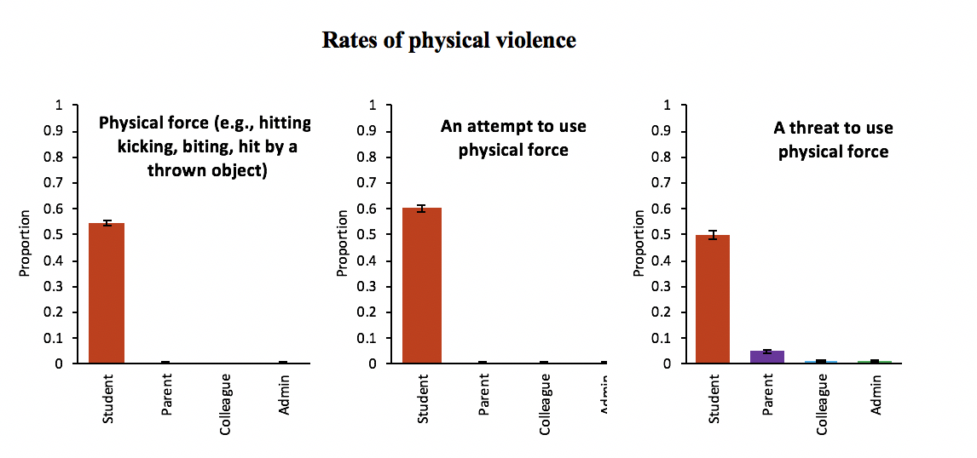
Figure 1. Rates of harassment and violence experienced by survey respondents during the 2017-2018 school year (Facing the Facts report). Proportion refers to percentage of all survey respondents (i.e. 0.5 would be 50 per cent of all respondents).

Intersecting Factors that can Increase Vulnerability
The researchers noted that vulnerability to harassment and violence can be heightened by factors such as gender, race, disability and sexual orientation. Survey respondents who identified as women, racialized, disabled, and/or identified as lesbian, gay, bisexual, transgender or queer (2SLGBTQ+) experienced statistically higher levels of harassment and violence. Women with disabilities reported the highest levels of total harassment. In their key findings, Dr. Santor and Dr. Bruckert stated that harassment and violence against elementary school educators is gendered violence.

Barriers to Reporting
Dr. Santor and Dr. Bruckert found a number of systemic barriers to reporting harassment and violence. Reasons for not making reports included, for example, lack of time, being discouraged from reporting and concerns about repercussions. Experiences of feeling discouraged from reporting included the fear of reprisal. Some survey respondents perceived that their administrators were unable or unwilling to address the reported issue.

Impact on Health, Job Performance and Student Well-Being
Analysis of survey responses indicated that experiences of harassment and violence were associated with poorer physical and mental health and lower job performance. Survey respondents expressed concerns for the well-being and safety of students who witness harassment and violence at school, and the related disruptions to the learning environment. Some of these concerns are captured in Figure 2 below.
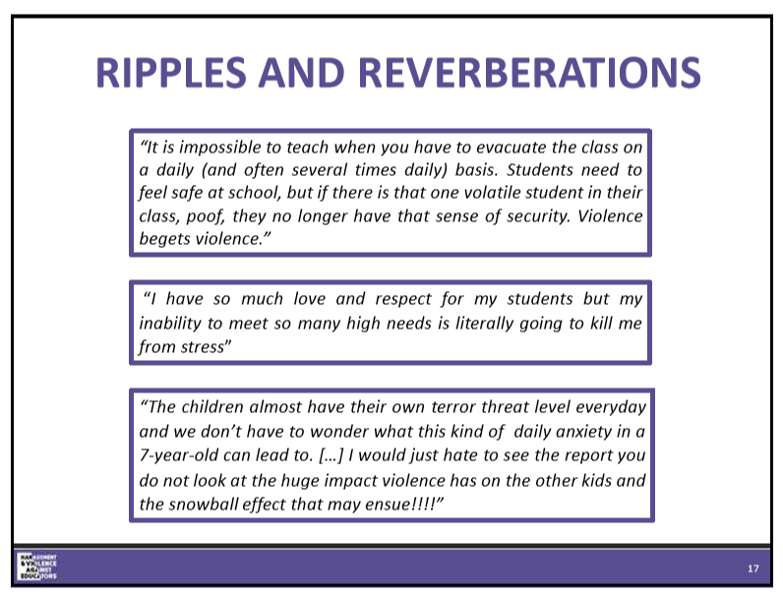
Figure 2: Concerns about the learning environment.

Societal Changes
The researchers spoke to a number of factors that correspond with the rising rates of harassment and violence in elementary schools. For example, societal factors such as economic stress and increased mental health difficulties among students. Shifts in education policy and funding cuts have made it more difficult for school boards to meet individual student needs.
Dr. Santor and Dr. Bruckert offered a number of suggestions in their report for taking action on harassment and violence in elementary schools. Five examples from the presentation are included.
- The adoption of a population health approach that examines a broad range of factors and conditions influencing harassment and violence in schools.
- Ongoing monitoring of workplace harassment and violence including the development of strategies to address the vulnerability of designated groups.
- Ensure that polices and protocols concerning harassment and violence are understood and consistently applied.
- Increased resources to help the most vulnerable students get the support they need to flourish and learn.
- Resources to support educators and address their mental and physical health needs in the context of the escalating workplace harassment and violence.

Questions and Comments
Q: A participant expressed hope that school boards, the government and teachers who have not come forward yet, can take a long look at these research findings. “We are hurting – all our children and all the people in our schools.”
A: Dr. Bruckert welcomed the comment and noted that her research partnership with Dr. Santor began as a result of a 15-minute meeting and led to something that they hope to continue for 10 more years. Dr. Bruckert wished the Symposium success, hoping for concrete outcomes that could make a difference.

Annie Kidder, Executive Director, People for Education
Are We Providing Students with the Resources and Supports They Need to Thrive - Now and Into the Future?
Annie Kidder is the Executive Director and a founder of People for Education. An expert on education policy and funding, Kidder provides advice to policy-makers and government. Annie Kidder is the recipient of numerous awards, most recently in 2018, an honourary doctorate from York University.

Background
As part of its strategic priority, People for Education provides evidence and uses research to advance public education’s role and to help ensure that all young people have an equitable chance for long-term success. In addition to its Annual School Survey, based on responses from more than 1,200 principals across Ontario, People for Education produces special reports on subjects ranging from the funding formula to special education.
Just prior to the Symposium, People for Education released the report, Supporting Students’ Mental Health: A Collective Responsibility (People for Education, 2019). Kidder’s presentation to the Symposium focused on the strengths of the public education system; student mental health; resources and supports for schools and families; and the skills and competencies for good mental health.

Key Ideas and Next Steps

Key Ideas
- The economics of public education is an investment in the future.
- School violence is a leading concern.
- There are more students struggling with mental health issues while supports and services are falling short.
- Access to mental health resources and supports varies across the province.
- The story of The Dish with One Spoon, as described by Aqua, can remind all about shared responsibility.

Next Steps
- Invest in children for long-term health, social and economic outcomes for families and individuals.
- Understand and address the root causes of violence in schools.
- Engage in collaborative planning to support a whole school approach to mental health.
- Ensure equitable access to mental health professionals and supports for students all across the province.
- Encourage cooperation and the integration of services and supports, including those between ministries.

Presentation Highlights

The Dish with One Spoon
Kidder began by reminding the audience about The Dish with One Spoon story described by Aqua Nibii Waawaaskone at the Symposium’s opening ceremony (Nibii Waawaaskone, 2019). Kidder said that, “The Dish with One Spoon story reminds us to work together, collaboratively and co-operatively.”

The Strengths and Needs of Public Education
Kidder spoke to the strengths of public education in Canada and Ontario as well as the challenges and stated that publicly funded education is key to a thriving, democratic, fair, prosperous and sustainable society. Noting that the academic achievements of our students are internationally recognized, Kidder cautioned that the increasing needs for student services and supports are not being met.

Root Causes of Violence
Kidder referenced the ETFO resource provided at the Symposium, The Top Twenty in 2018 (Appendix 2), which identifies the occupations of education assistant, teacher, early childhood educator and principal, as those having among the highest numbers of lost-time injuries from workplace violence in Ontario. Kidder emphasized the importance of understanding and addressing the root causes of violence in schools.

Valuing the Work of Educators
To audience applause, Kidder said that educators have one of the most important jobs in our society. Educators ensure that the next generation can innovate, imagine, adapt, continue to learn, contribute to the world that they live in and understand how they are connected to the people around them.

Return on Investing in Children
Referencing the Conference Board of Canada, Kidder described the economics of public education as an investment in our children highlighting that when, “we invest in our children, we all benefit.” The return on investment includes increased future productivity, higher income, better health, upward mobility and reduced social costs as demonstrated in the following Figure 3.

Figure 3. The economic benefits of investing in public.

Student Mental Health Issues
Referring to the findings of People for Education’s report on student mental health, Kidder noted that there are more students struggling with mental health issues. Many principals expressed concern that student challenges were beyond the training and capacity of educators and staff. They identified the need for increased in-school supports, in particular for the services of mental health professionals, as in Figure 4 below.
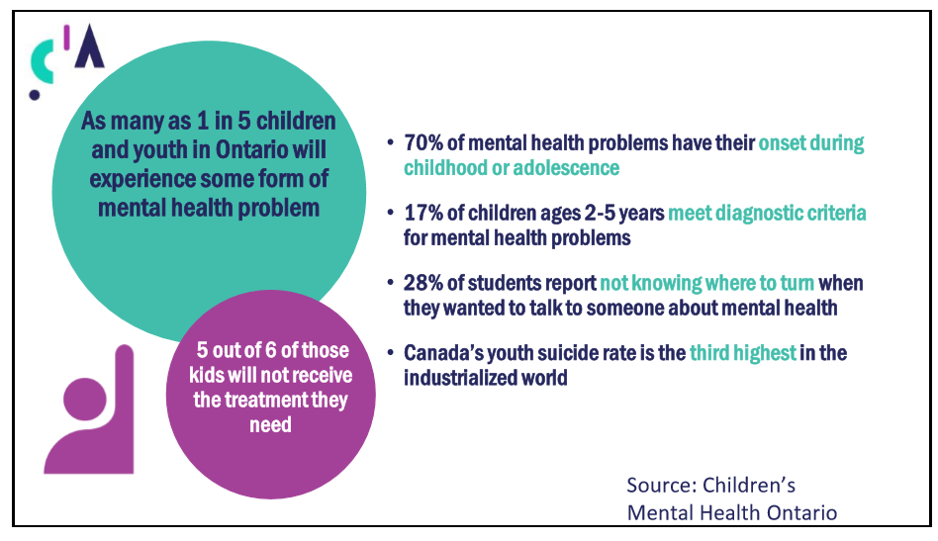
Figure 4. Mental health problems among Ontario’s children and youth.

Geography and Access
Kidder discussed People for Education’s latest findings on geography and its impact on school-based mental health resources and supports, as set out in its Annual Report of 2019 (People for Education, 2019) and noted that schools in rural and remote areas are less likely to have access to mental health supports than schools in other regions providing the example of access to a psychologist as found in Figure 5 following.
In addition, principals in French-language school boards have identified that francophone communities were underserved regarding mental health supports, including access to francophone professionals.
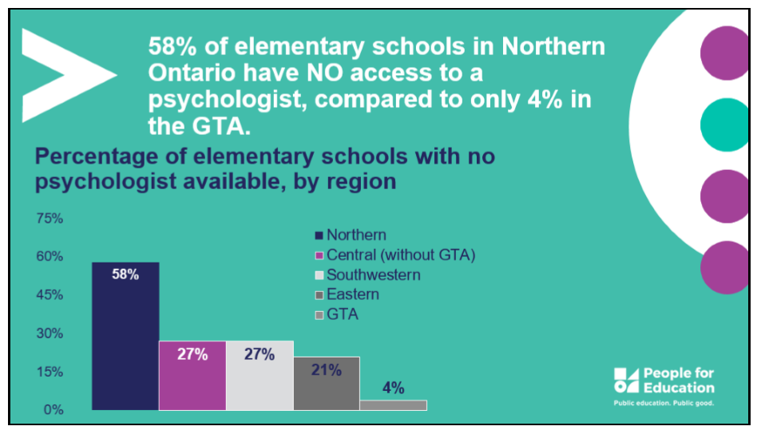
Figure 5. Geography and access to psychologists in Ontario schools.

The New Basics
Kidder invited the Symposium to consider the ‘New Basics’ for public education. The ‘New Basics’ include collaboration; thinking creatively and critically; learning to learn; communicating effectively; and developing a sense of self and society. Rather than being ‘soft skills’, Kidder explained that the ‘New Basics’ are not only foundational for content-learning across traditional subject areas, they are increasingly recognized as essential competencies and skills for future success.

Systems Can Change
In closing, Kidder stated that systems can change, even though change may be slow and difficult. It is possible to push at systems and make them change. One can learn from other systems, and one can also identify the things that are easy to change within current systems.

Questions and Comments
Q: Thank you for addressing us as educators. We are not all termed “teachers” and we appreciate your inclusiveness. The participant noted that the word “violence” may be overused in these conversations and to consider introducing language about the health of children. Concerns were shared that the initial levels of supports and services for the integrated classroom model have been reduced. School violence tends to focus only on what the education sector must do and that the role of other ministries should be included. How we can collectively move together in education as one unit to gather the collective necessary, supports that were at one time available, “but seem to be in the mist, somewhere that we cannot see.”
A: In response, Kidder referred again to The Dish with One Spoon as a model for shared responsibility and described the school as an ecosystem of people, resources and community connections. Kidder said, assuming that schools should deal with the crisis alone allows for the belief that, “It’s not my problem, it is someone else’s problem” and affirmed the need for co-operation and integration of services and supports, including those between ministries.

Chris Broadbent (TDSB), Janice McCoy (OCDSB), Lee-Anne Feltham (OCETFO/FEEO)
Expert Panel: Reporting Processes That Contribute to the Prevention and Control of Health and Safety Concerns.
The Role of Joint Health and Safety Committees
Chris Broadbent is the former Health and Safety Manager of the Toronto District School Board and is currently the Senior Health and Safety Consultant for the School Boards’ Cooperative Inc. (SBCI). Janice McCoy is the Superintendent of Human Resources for the Ottawa-Carleton District School Board (ODCSB) and serves as co-chair of the Joint Health and Safety Committee (JHSC). Lee-Anne Feltham is the Health and Safety Officer for the Ottawa-Carleton ETFO Local and serves as co-chair to the JHSC. The panel moderator was Valence Young, ETFO Executive Assistant.

Background
Expert panel members Chris Broadbent, Janice McCoy and Lee-Ann Feltham have extensive leadership roles for health and safety in school board workplaces. The panel discussion focused on reporting processes for health and safety, the role of the Joint Health and Safety Committee and the value of good working relationships.

Key Ideas and Next Steps

Key Ideas
- Use workplace violence data to ask questions about what trends need to be identified and what measures need to be put into place.
- It can be easier for a worker to report a physical injury resulting from a fall in the school yard than to report a mental or physical injury resulting from recurrent workplace violence.
- The Provincial Working Group on Health and Safety (PWGHS) has done important work to support resource development and to make recommendations to the government regarding workplace violence.
- The main strength of the JHSC is simply that it functions as a joint committee with both management and workers.
- Too much time is spent disputing language, and not enough time invested in finding solutions, though the expertise to do so is there.

Next Steps
- Encourage all staff, including principals, to submit reports about violent incidents because reporting processes for health and safety are a critical part of health and safety culture.
- Recognize that a worker’s mental or physical injury resulting from a workplace violence incident is a workplace injury.
- The required online reporting system for workplace violence and serious student incidents has the potential to provide better province-wide data.
- The JHSC can make recommendations to the school board. It can demonstrate collaboration on addressing workplace violence issues.
- Find opportunities to work across departments, in school boards, identifying commonalities towards a shared goal.

Panel Highlights
Q: How Do Current Reporting Processes Contribute to the Health and Safety of Workers in Your School Board?

Janice McCoy
McCoy stated that the Ottawa-Carleton District School Board (OCDSB) places an emphasis on encouraging staff to submit reports because reporting processes for health and safety are a critical part of health and safety culture. The information in the reports helps to identify concerns for response and helps to flag specific concerns such as the frequency and nature of the incident. The school board’s workplace violence reporting form has a section that allows the worker to identify if they want the report to be brought to the attention of the JHSC.

Chris Broadbent
Broadbent spoke to the progress of the Provincial Working Group on Health and Safety to clarify the reporting process for workplace violence in school boards through the creation of a graphic tool known as the “Road Map” and explained that the Road Map charts reporting process for workplace violence in school boards follows under three statutes: The Education Act, the Occupational Health and Safety Act and the Workplace Safety and Insurance Act. Broadbent noted that the Ministry of Education followed up with The Road Map Training Resource for Principals and Staff: Workplace Violence Reporting Process in School Boards (Ontario Ministry of Education, 2019). Broadbent stated that the question remains, “How can reporting lead to prevention?”
Note: The Provincial Working Group on Health and Safety was established in January 2016 through the 2014-17 collective bargaining process. The working group is composed of representatives from school boards, teacher federations, education worker unions and the government. It has a mandate to review system-wide health and safety issues and make recommendations to support their resolution (Ontario Ministry of Education, 2018).
Q: What are the Strengths of your Joint Health and Safety Committee?

Lee-Anne Feltham
Feltham noted that Ontario’s Occupational Health and Safety Act (OHSA) has a provision that can allow an employer to have one central JHSC for multiple workplace locations, the “multi-site JHSC”. The OCDSB operates a multi-site JHSC with a central committee. There is an elected worker safety representative at each workplace location who completes a monthly health and safety inspection. There is a flagging option on the inspection report for the worker representative to indicate a concern to the JHSC.
Feltham stated that the main strength of the JHSC is simply that it functions as a joint committee with both management and workers. Its additional strengths are the opportunities for internal and external collaboration.
The school board’s JHSC meet on a monthly basis. Feltham explained that the JHSC has a number of duties and powers, for example: the JHSC can make recommendations to the employer for the improvement of worker health and safety. Designated JHSC members attend work refusals; investigate critical injuries; are present at industrial hygiene testing; and accompany Ministry of Labour inspectors.
Feltham explained that the school board’s JHSC has two sub-committees: the workplace safety inspection sub-committee, which reviews inspection reports, and the violence sub-committee. The sub-committees meet monthly. In addition, a new working group can be created when trends or needs are identified. Working groups look at anything health and safety-related with the overall goal of reducing workplace illness and injury.
The school board has developed a number of health and safety reporting forms in consultation with the JHSC. Most of these reports are online. Feltham noted one example, the school board’s Occupational Health and Safety Concern Form, which performs as a “catch all” for a potential or existing hazard. Feltham emphasized that there has been significant work done at the JHSC to define The Internal Responsibility System (IRS) for health and safety which provides direction for next steps within the reporting process (Ontario Ministry of Labour, 2019).

Janice McCoy
McCoy responded by stressing the importance of the appropriate use of workplace violence data, asking questions about what trends need to be identified, and what measures need to be put into place. McCoy noted that the school board is committed to an ongoing review of the data. For example, the superintendent from the special education department also attends the JHSC’s workplace violence subcommittee meetings. The subcommittee studies data, confirms if supports are in place, determines what can be done in addition to current supports and identifies new issues and concerns. McCoy stated that there is value in finding opportunities to work across departments, identifying commonalities in working towards a shared goal.
Q: What about violence, harassment, threats and bullying that come from outside the school community? How can reporting systems be used to respond to those occurrences?

Chris Broadbent
Broadbent noted that the reporting system should include concerns about individuals external to the school community who may cause harm within it and that perpetrators may include parents. Administrators are also vulnerable in situations involving persons from outside the school. Formal procedures to support staff and administrators, who are dealing with these incidents, can be helpful.

Janice McCoy
McCoy responded that the school board has developed an additional general safety plan template to assist with dealing with a person who is a threat from outside of the school. The school board’s workplace violence and harassment policies and procedures include measures for dealing with the risks from external sources.
Q: There has been provincial interest in clarifying and streamlining the reporting requirements for violent incidents in schools which could allow for the collection of more accurate data. What are some challenges with making effective use of reporting data?

Chris Broadbent
Broadbent said that there is a need to find a better way to integrate all reporting systems for health and safety. This would lead to a better understanding of the complexity and range of workplace violence injuries experienced by education workers.
Q: That speaks to Lee-Anne’s earlier point about the Internal Responsibility System which is also part of a healthier, safer workplace culture overall. Reporting systems for workplace injury and illness are incredibly important as an underpinning to workplace culture. Any comments?

Lee-Anne Feltham
Feltham commented that it is often easier for a worker to report a physical injury resulting from a fall in the school yard than to report a mental or physical injury resulting from recurrent workplace violence. Reported injuries, for statistics, are often discussed only in terms of lost-time or medical attention and that adequate data related to mental health injuries is not being captured. A mental health issue, resulting from a workplace violence incident, is not necessarily treated as workplace injury and is therefore not captured in statistics. The definition of “injury” is evolving. In terms of the barriers to reporting, what are they?

Janice McCoy
McCoy noted that through the lens of occupational health and safety, completing reports about school violence often necessitates identifying students as the source of the hazard, and that is uncomfortable and reminded us that we operate under a complex intersection of legal issues including for example: The Occupational Health and Safety Act; The Education Act; The Human Rights Code; and The Municipal Freedom of Information and Protection of Privacy Act. These statutes can have competing obligations. McCoy also noted that it is challenging to encourage administrators to report and stressed the need to ensure that all school board employees report incidences.

Lee-Anne Feltham
There is a common sentiment, said Feltham, that reporting will not amount to action. Instead, health and safety culture needs to be bolstered. Individuals need to see results in response to reports. Feltham noted that the school board’s online reporting system has helped to make reporting and response quicker. The online system also helps the JHSC to reinforce reported incidents. Feltham noted that if hazards can be identified, they can be assessed and controlled.

Chris Broadbent
Broadbent expressed interest in looking forward to the ongoing work on this issue and the opportunity to focus more on aspects of workplace violence prevention. Being able to collect and then leverage data for workplace violence prevention are very important.

Janice McCoy
McCoy prioritized the need to collectively agree to work together to serve our students; keep them in schools; and provide the services and support they need - while acknowledging individual obligations under the legislation. McCoy expressed the need to find the solutions, explaining that too much time is spent disputing language, and not enough time invested in finding solutions - even though the expertise is available to do so.
McCoy emphasized that solutions require collaboration, for example, when identifying the supports that can be provided to our students. Collaboration includes looking at the issues through the lens of both employee needs and student needs.

Lee-Anne Feltham
Feltham indicated that, from first-hand experience as a Special Education teacher, one of the best ways to support students, is to have well-prepared staff. Feltham stated that the supports put in place for occupational health and safety will support our students.

Chris Broadbent
Broadbent said that it is imperative to find a way to ensure both students and workers are protected by keeping both the Ministry of Education and the Ministry of Labour at the table.

Questions and Comments
Q: Has there been any monitoring of safety plan implementation in the context of workplace health and safety?
A: Feltham responded that safety plans are a current focus at the JHSC. Representatives from the Learning Support Services department are now part of the JHSC’s violence subcommittee. Even though violence is an occupational health and safety hazard, it is the representatives from Learning Support Services who generally support the development of safety plans. The JHSC has identified the need to collaborate with Learning Support Services and determine what are the best practices for the safety plans.
McCoy added that in terms of the monitoring and the implementation of the safety plan, the board has Itinerant Education Assistants based at the board office. These staff are deployed to schools to help address specific issues. Part of their role is to go in and observe, and if there is a safety plan, to monitor and provide feedback.
A participant stated that two years ago, ETFO York Region had a symposium on violence in the classroom. The invitation list included numerous school council chairs, fewer than 11 chairs attended. In the context of collaboration, where exactly do school councils fit into all of this?
McCoy further contributed the OCDSB did a thought exchange when developing its new strategic plan. Staff, parents and community members were invited to participate in the thought exchange survey. Participants were asked open-ended questions. For the purposes of our discussion today, survey findings reflected two themes from parents: 1) unfilled staff absences; and 2) student behaviors in classrooms. McCoy said these are areas that districts need to be thinking about moving forward. What resonated was that the board was hearing about these concerns from parents, not only internally.
A participant commented that it is difficult for the public to understand what is really happening in schools. The participant also described how the participant’s own mother was surprised to learn that an evacuation process could be part of her working day as an occasional teacher. The participant asked if the Ministry of Education is paying attention to the workplace violence data gathered from health and safety reporting.
Broadbent stated that school boards are at various stages of implementing the required online reporting system for workplace violence and serious student incidents, even though the Ministry of Education had provided money for this purpose (Ontario Ministry of Education, 2018). The process of integration with other online systems is a factor that has delayed full implementation. Broadbent suggested that the Ministry may be waiting for the full data to come in as a result of the new online reporting systems becoming operational across the province. Broadbent estimated that having all school boards collecting online workplace violence data and having the Ministry of Education determine where to focus is at least a year out from implementation.
Q: In British Columbia, safety plans are more worker-based. In Ontario, do the school boards have behavior plans that go along with these safety plans for students, and if so, what are the differences between behavior and safety plans?
A: Feltham responded that the school board has student safety plans and general safety plans for non-students and noted that when safety plans were first rolled out, special education staff were mainly responsible for safety plans, behavior plans and Individual Education Plans (IEP), and these documents began to look very similar. From a health and safety perspective, Feltham would have preferred the use of the term “safe work procedure” instead of “safety plan,” making it easier to identify who would be responsible for writing the document.
Note: A brief summary of the differences between safety plans and behavior plans is provided in the Ministry of Education resource, Caring and Safe Schools in Ontario (Ontario Ministry of Education, 2010).
Further information on the use of safety plans and behaviour plans is provided in the Ministry of Labour resource, Workplace violence in school boards: A guide to the law (Ontario Ministry of Labour, 2019).

Discussion Groups
Symposium participants were invited to participate in one of six discussion groups about violence in schools. Although the discussion groups were scheduled for only 60 minutes in the morning program, the sharing of expertise during these conversations bodes well for future work.

Key Ideas and Next Steps - Collated from the Discussion Groups

Key Ideas
- Collaborate in new ways while “breaking down silos.” Develop a shared understanding of the underlying factors related to school violence – in and beyond school communities.
- What are the leading practices and initiatives for dealing with workplace violence within and beyond the education sector?
- The Provincial Working Group on Health and Safety (PWCHS) is a positive example of collaboration.
- There are numerous barriers to an effective reporting process for violent incidents in schools ranging from workplace culture that deters reporting to complex and time-consuming steps.
- The JHSC has the power to make recommendations for the improvement of the health and safety of workers.
- The National Standard of Canada for Psychological Health and Safety in the Workplace could be adopted by school boards.
- Witnessing school violence can be harmful to staff and students. School violence disrupts teaching and learning.
- Under-funding leads to shortfalls in programs and services for individual students, including early identification.

Next Steps
- Collaborative work to align efforts on school violence can expand to include expertise from, for example, Ministry of Health, public health, community and parent organizations and mental health agencies.
- Identify leading practices and initiatives that can inform solution-seeking on violence in schools.
- Invite the Ministry of Health to attend the PWGHS.
- The required online reporting system for workplace violence and serious student incidents needs to be operational.
- Training and supports for staff and principals on reporting processes.
- JHSC recommendations to the employer, including for the improvement of workplace mental health.
- Recognize the effects of violence in schools on teaching, learning and well-being in related discussions and decision-making.
- Afford funding for programs and services, including early identification, for individual students.

Discussion Group Highlights
The following highlights focus on the three leading topics that emerged: collaboration; reporting processes; and mental health. Groups were asked to make rough notes that briefly summarized their discussions for use in writing the Summary Report. Quoted comments are excerpts from the written notes provided by the discussion groups.

The Need for New and Better Models of Collaboration
There was recognition that the issue of violence in schools requires supports from within and beyond the education sector. The leading theme among discussion groups was the need to encourage collaboration in new ways while “breaking down silos.” For example:
“Address underlying factors with parents, families, community organizations and public health, collaboratively.”
“What we do next needs to be purposeful and done with intent. Engaging with other ministries, community agencies and SCCs [School Community Councils].”
In education, “four different areas - equity and inclusion, safe and healthy schools, School Mental Health Ontario, and curriculum/pathways to success” are “working in their silos, but are not working together for overall health and safety.”
The ongoing Provincial Working Group on Health and Safety (PWGHS) was cited as a positive example of collaboration, “Able to get Ministry of Ed, MOL, school boards and unions/federations together.” There was a suggestion that the Ministry of Health be invited to attend the PWGHS. The strategic benefits of learning from other organizations and other sectors such as health care were identified, “Communicating with boards, schools and other partners across the community to find best practices.”
Discussion groups noted the need for more collaboration on issues related to violence in schools within the school board itself, for example: planning for a school transfer when safety issues are a concern; safety plan development; health and safety training; and encouraging the reporting of violent incidents. One of the discussion groups identified the importance of clearly messaging the scope of violence in schools:
“We have to lift the veil of secrecy and be honest with parents and the public and all stakeholders about the true scope of the issue – the reality of what’s actually happening school – boards don’t want to be open and honest about it. Be truthful, e.g. don’t call an evacuation a ‘library walk’. The data doesn’t tell the full story as there is under-reporting. It needs to be named, the full impact shared (e.g., safety, bystander trauma, loss of instructional time) and a plan of action with resources put in place. Root causes such as lack of supports for families need to be identified, and supports put in place (or back in place based on cuts during times of so-called ‘austerity’).”

Barriers to Reporting
The reporting process for violent incidents is complex and time demanding for both staff and administrators, for example:
“Time to fill in reports. How do you support the person, have time to fill it in, but also follow up after form? How do you support people/aids/contract and new teachers to feel secure to fill in reports? How do [you] follow up for occasional staff?”
“How can they [the principal] make time to work with 24 different ‘cases’ requiring safety plans?”
Aspects of workplace culture that can discourage reporting were also identified, for example: “Issues of racialized educators, let’s not call them ‘too sensitive’, change the culture of blaming the workers.”
The negative influence of violence in schools on the teaching and learning environment was recognized:
“Board is VERY interested in data for literacy and math, they need to be just as interested in the violence and harassment data. There needs to be recognition at the ministry level that you can put all the resources/money into math training but when the learning is disrupted by violence and harassment, the teaching can’t be completed. Step back and look at what the priorities are. Teachers/educators need to be able to teach. Bring in the supports/experts that can do the diagnosing, treatment etc. Teachers need the help; we can’t be everything to everyone.”
There were concerns that some school board reporting templates were missing data markers for recording important information about violent incidents, for example: mental injury, the use of sick leave with or without a Workplace Safety and Insurance Board (WSIB) claim, and the occurrence of classroom evacuations. There was concern that “mitigating factors” relating to serious student incidents may be used incorrectly to deter reporting requirements for workplace violence under the Occupational Health and Safety Act.
It was understood that school boards are moving towards “one fulsome reporting online system across the province” (Ontario Ministry of Education, 2018) for reporting violent incidents and serious student incidents, though the process appears to be slow.
Note: Please refer to The Road Map to Reporting Workplace Violence in Ontario School Boards for a summary of reporting requirements about mitigating and other factors (Ontario Regulation 472/07), serious student incidents (Education Act) and workplace violence incidents (Occupational Health and Safety Act) (Ontario Ministry of Education, 2019).

Teaching, Learning and Well-Being
In addition to the physical harms of school violence, discussion groups were also concerned about the mental stress of witnessing school violence for staff and students, “What is the impact of vicarious trauma on our teachers (educators) and students?”
There is a need to, “Take a real look at the impact of witnessing violence on learning.” The mental stress of anticipating violence in the classroom was also recognized, “How can we do our job if we are anxious every time we walk in the door?” The question was asked, “How do we prevent the cascade effect - violence in Kindergarten leads to violence in high school?”
It was noted that additional supports are needed for integrated classrooms to work more effectively, “We are not doing integration the way it was meant to be done.” Social and Emotional Learning (SEL) programs were regarded as potentially effective in helping to support student well-being. There was interest in piloting SEL programs in Kindergarten.
Student trustees were recognized as resources for assisting with the development of mental health resources “for student by students.” The importance of early identification and intervention for students with emerging mental health issues was emphasized.
The power of the Joint Health and Safety Committee to make recommendations for the improvement of the health and safety of workers was recognized: “Use JHSC to create/make recommendations to address mental, psychological health and safety.” In addition, it was suggested that school boards adopt The National Standard of Canada for Psychological Health and Safety in the Workplace (The Mental Health Commission of Canada, 2013).

Dr. Peter Smith, Institute for Work and Health
Gender Differences in Injuries Attributed to Workplace Violence in Ontario
Dr. Peter Smith is an associate scientific director and a senior scientist at the Institute for Work & Health (IWH) in Toronto, Ontario and holds appointments as an associate professor in the Dalla Lana School of Public Health at the University of Toronto, and in the School of Population Health and Preventive Medicine at Monash University in Australia. Dr. Smith holds one of nine Canadian Institutes of Health Research chairs in Gender, Work and Health (Canadian Institutes of Health Research, 2019).

Background
Dr. Smith’s presentation focused on a recent study by the Institute of Work and Health, entitled, Gender differences in injuries attribute to workplace violence in Ontario 2002-2015 (Chen, Smith, & Mustard, 2019). This study was published in the January 2019 issue of Occupational and Environmental Medicine (OEM). In their research, Chen, Smith and Mustard estimated trends in injuries attributed to workplace violence among men and women in Ontario over the period 2002-2015. They looked at the number of WSIB lost-time claims attributed to workplace violence. They also reviewed the number of emergency department visits across all Ontario hospitals due to assaults at work. The study focused on describing important differences in the incidence of these injuries between men and women.

Key Ideas and Next Steps

Key ideas
- Lost-time injury rates from workplace violence are increasing for both men and women in Ontario’s education sector. The rate for female education workers now surpasses both male and female heath care workers. The increased numbers of severe injuries among education workers, including intracranial injuries, are cause for concern.
- Although Ontario workplaces are required to collect data about workplace violence events, the systems for doing so are unevenly implemented.
- The relative risks of workplace violence can change over time for men and women and can differ across industries during the same period.
- School-based reports and lost-time injury data do not provide enough information about school violence.

Next Steps
- Make lost-time injury data part of the discussion about the harm of school violence and the need for prevention. Obtain a better understanding of the burden of workplace violence among men and women in education occupations through data analysis and research to assess prevention efforts over time.
- Develop better and more coordinated systems to capture workplace violence events and details about these events.
- Include the concepts of sex and gender in occupational health and safety research to better inform research outcomes.
- Conduct a large-base survey designed to understand differences across schools, geography and roles within the education sector, include the experiences of workers and students.

Presentation Highlights
Dr. Smith presented an overview of the research findings and identified how the new findings may inform policy, practice and further research.

Education Workers and Rising Rates of Workplace Violence
Even though jurisdictions across Canada have introduced legislation to address workplace violence, the number of injuries attributed to workplace violence has not declined. Workplace violence prevention efforts in Ontario have largely focused on the health care sector. The study found that workers in the health care and education sectors have the highest rates of lost-time injury from violent incidents.
Dr. Smith noted that the risk of experiencing workplace violence has been steadily rising among women in the education sector for over a decade. In the last half of the 2002-2015 research period, the rates of workplace violence experienced by female education workers made them four to six times more likely than male education workers to require time off work due to physical assaults experienced on the job (Figure 6). The rate of Workplace Safety and Insurance Board (WSIB) lost-time claims due to workplace violence for women in the education sector now surpasses the rate for both men and women in the health care sector (Chen, Smith, & Mustard, 2019).
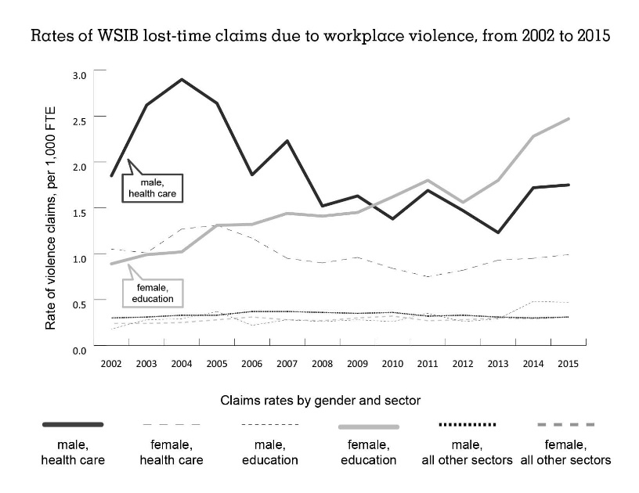
Figure 6. Rates of WSIB lost-time claims due to workplace violence 2002-2015. Institute of Work and Health, At Work 96 (Spring 2019) (Chen, Smith, & Mustard, 2019)

Expanding the Scope of Research About Workplace Violence
In his presentation, Dr. Smith emphasized the importance of using research to assist with trying to understand what these increases in rates of workplace violence mean. For example: Are these increased rates due to factors such as changes in the nature of work? Are these changes concentrated in specific occupations? How may concepts such as gender (i.e. social and structural differences between men and women) and sex (i.e. biological, psychological and environmental vulnerability differences) contribute to this understanding (Institute of Work and Health, 2019)?
Dr. Smith also noted that while workplace violence is an occupational health and safety issue, it is also a quality improvement issue, as workplace violence events directly impact the quality of education in a classroom or school setting.

What Does Lost-Time Data Tell Us About Who is Getting Hurt?
Throughout the 2002-2015 research period, the numbers of lost-time injuries from violent incidents in Ontario’s education sector have continued to rise. During this period, most of these lost-time claims were experienced by elementary and secondary teacher assistants, with the greatest annual increases in the numbers of violent incidents as demonstrated in Figure 7 below.
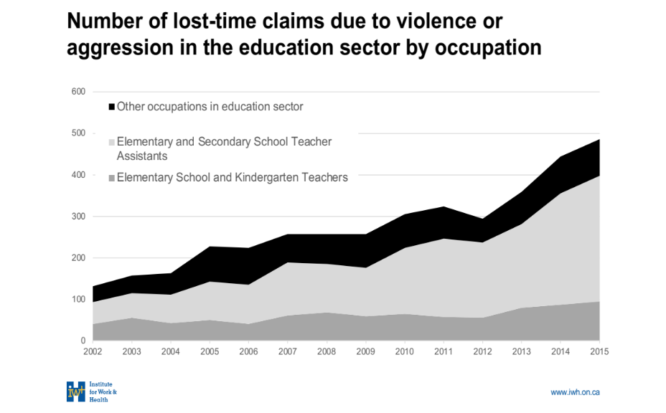
Figure 7. Lost-time claims due to violence in Ontario’s education sector by occupation

Ontario education workers suffer varied and serious lost-time injuries from workplace violence. Dr. Smith provided further information about the nature of these injuries. Through the use of the following graph, Figure 8, Dr. Smith drew particular attention to the rising rates of intracranial injuries (traumatic brain injury) resulting from violent incidents at work.
Figure 8. Lost-time claims due to violence in Ontario’s education sector by nature of injury

How Could New Findings Impact Policy, Practice and Future Research?
Although Ontario workplaces are required to collect data about workplace violence events, the systems for doing so are unevenly implemented. In the education sector, incidents of workplace violence might be reported in multiple ways to multiple systems, and there is no coordination across these systems to understand the number of unique events. To better understand the burden of workplace violence, and to assess prevention efforts over time, Dr. Smith stated that more coordinated systems to capture workplace violence events, and details about these events, needs to be developed. The concepts of sex and gender must be included when researching workplace violence to better inform research outcomes, both in terms of understanding who experiences workplace violence and also who are the perpetrators of workplace violence.

Better Research Needed
Dr. Smith stated that in addressing school violence, the school-based reports are not enough. Lost-time claim data is just the tip of the iceberg and that between 50 and 200 other workplace violence events occur for every lost-time claim reported. Dr. Smith proposed that, to really understand the burden of workplace violence in the education sector, a large-base survey designed to understand differences across schools, geography and roles in necessary. Dr. Smith explained that not only does one need to understand the experiences of students, one needs to also understand the experience of educators, administrators and other individuals who work within our school communities and can be achieved by asking people about their experiences, not just relying on lost-time claim data.

Questions and Comments
Q: Has there has been a move to study Post-Traumatic Stress Disorder (PTSD) as an outcome of workplace violence.
A: Dr. Smith acknowledged the need to better understand the various health consequences of workplace violence and affirmed the residual effects of PTSD; stating that a better understand of PTSD and its symptoms is needed in relation to all types of workplace violence along with the need to avoid placing blame on those who suffer from PTSD.
Q: A participant noted that hospitals are being mandated to publicly report incidents of violence and asked Smith to comment on the potential value of such public reporting for the education sector.
A: Dr. Smith was unsure what the value of mandated public reporting would be from the public perspective and to consider the potential value of mandated reporting for violent incidents from the worker’s perspective. Dr. Smith stated that those with higher positions of power may pay more attention to the number of violent incidents if there was mandated reporting. As a result, the issue of workplace violence incidents in the education sector may demand a place on important agendas. Dr. Smith noted that the effects of mandated reporting may lead to wanting to know more about the issues and encourage increased reporting to get a better sense of the statistics.

Christine Preece, St. Clair Catholic District School Board
Schools Cannot Do It Alone
As the Mental Health and Well-Being Systems Lead for the St. Clair Catholic District School Board and Chair of the Ontario Healthy Schools Coalition, Christine Preece has more than 25 years of experience in the both the education and health sectors.
Christine Preece spoke to the benefits of stronger and more effective links between education and health partners for the benefit of both students and staff in our school boards. The work of the Ontario Healthy Schools Coalition (OHSC) was highlighted as an example of advocacy and support for healthy school communities.

Key Ideas and Next Steps

Key Ideas
- Schools cannot deal with issues such as violence and mental health on their own.
- Addressing health disparities must be part of our education and social reform.
- Exposure to adversity can activate the child’s stress response with long-term health consequences.
- Student mental health is a big challenge for 21st century learning.
- We need to advocate together rather than against each other.

Next Steps
- Adopt an interconnected systems approach to the issues of school violence and mental health. Engage supports between ministries, public health, school boards, agencies, organizations, services, students and families.
- Include the Social Determinants of Health when considering root causes.
- Screen for Adverse Childhood Experiences* with supports for early intervention and cross-sector, coordinated care.
- Break the stigma of student mental health through advocacy and engaging student leaders.
- Business, government, media, schools, families, municipalities and social and health services need to support educators in their work.
*Centers for Disease Control and Prevention (2019). Preventing Adverse Childhood Experiences (ACEs).

Presentation Highlights

Health Factors and Education Outcomes
Christine Preece stated that addressing health disparities must be part of our education and social reform and that the recognition of the collective impact of violence in schools can invite empathy and collaboration.
The audience was asked to consider narratives when talking with or about student perpetrators, and encouraged finding ways to frame more positive, health-focused language. For example, asking, “What happened?” instead of, “What is your problem?” can shift the lens to greater understanding. In addition, Preece suggested it may be time to consider restoring the school nurse and to establish heathy school coordinators in school boards. Preece reminded us that a child’s opportunity to play is essential for their development and well-being as detailed in Figure 9.
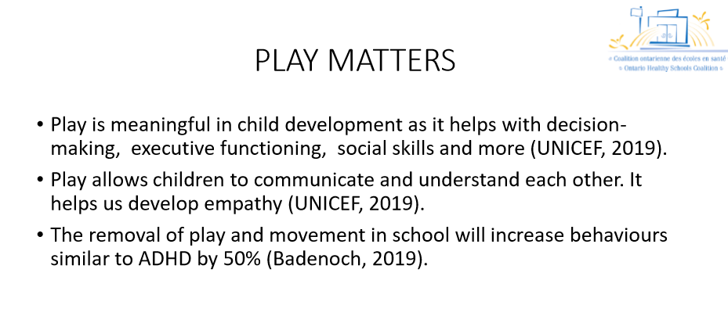
Figure 9. Play is meaningful to child development.

Social Determinants of Health
Chris Preece emphasized the need to consider the Social Determinants of Health as expressed by the World Health Organization as they relate to the health of children and youth (World Health Organization, 2020). These determinants include, for example, the social and economic factors that relate to an individual's place in society such as income, education, employment, access to health care and social services. Preece also stated that the well-being of families and children, including their mental health, can be challenged by negative factors such as poverty, food or housing insecurity and lack of access to social and medical supports as in Figure 10.
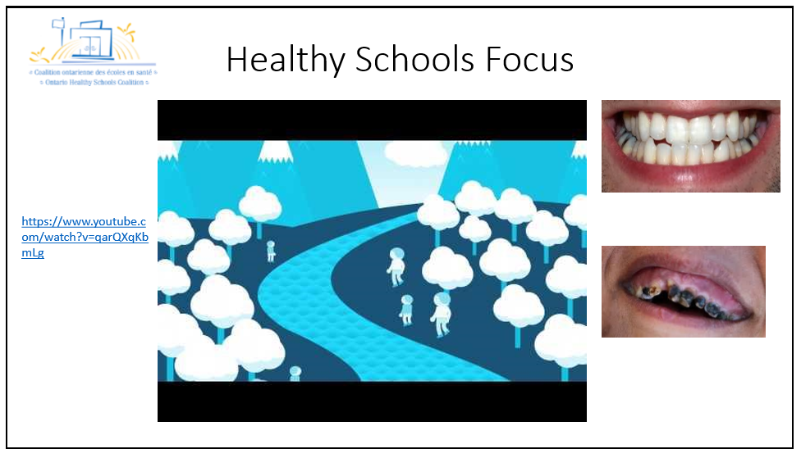
Figure 10. Children’s health is the foundation of health for life.

Adverse Childhood Experiences
Adverse Childhood Experiences (ACEs) are potentially traumatic events that occur in childhood (under the age of 18). Exposure to this adversity can activate the child’s stress response and have long-term consequences for health and behaviour.
Christine Preece suggested that every child entering the school system should be screened for ACEs. Referring to such a proposal in California, Preece explained that an ACEs screening program would require public education, routine screening for early detection of mental health needs, early intervention and cross-sector coordinated care.

Making a Difference
Chris Preece spoke to the need for a systems approach that is interconnected, with supports between and within ministries, school boards agencies, organizations and services and including students and families.
The need to focus on policies that match health outcomes was emphasised. Preece highlighted the need to advocate together rather than against each other and stressed the importance of taking care of each other and taking care of ourselves.
Chris Preece stated that the people who work in education need to be supported by business, government, media, schools, families, municipalities and social and health services. Preece provided a metaphor for this in “taking care of our own shoes first” as expressed with the picture in Figure 11.
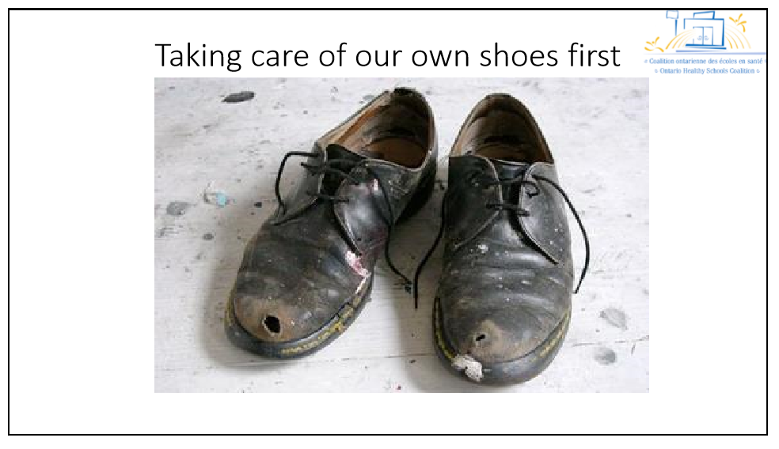
Figure 11. Care for our educators so that they can take care of students.

Questions and Comments
Q: A participant thanked Preece, saying that the presentation was very moving. In the role of a student trustee, the participant is always looking for ways to demonstrate advocacy about student well-being to fellow trustees in Ontario and further stated the need to break the stigma associated with talking about student mental health and identify the issue of student mental health as a big challenge for 21st century learning.
A: Preece thanked the participant, stating that youth engagement is a huge part of the student mental health movement. Youth can move mountains. They can advocate and they can make change and encouraged the participant to proceed and make a difference because you can.
Q: A participant noted that Public Health Ontario is preparing a national summary of intervention programs for Adverse Childhood Experiences, with a report to be released in the coming months. The participant expressed if with better data, we can have a better understanding of causes; but it is going to take collective action to address the issues around violence in schools.
Q: A participant asked, “How can we reconcile concerns about stigmatizing a student perpetrator of a violent incident with the need to acknowledge the lived experience of the educators who are victims of the violence?”
A: Preece said that a strength-based approach, which may consider the broader story, can be more effective than a deficit-based approach, which sometimes may refer negatively to the perpetrator rather than describe their behaviour. We need to look upstream to see the bigger picture for prevention and to figure out how we can work together to address healthy school environments.

Appendix 1: Participating Organizations

Association des Conseils Scolaires des Écoles Publiques de l’Ontario
Association of Early Childhood Educators Ontario
Avon Maitland District School Board
British Columbia Teachers' Federation
Canadian Broadcasting Corporation
Canadian Teachers' Federation
Canadian Union of Public Employees
Catholic Principals’ Council of Ontario
Dufferin-Peel Education Resource Workers’ Association
Elementary Teachers' Federation of Ontario
Indigenous Trustees' Council Ontario
Institute for Work and Health
Kinark Child and Family Services
Ministry of Education
Ministry of Health and Long-Term Care Ministry of Labour, Training and Skills Development
New Brunswick Teachers' Association
New Brunswick Teachers' Federation
Newfoundland and Labrador Teachers' Association
Occupational Health Clinics for Ontario Workers
Ontario Association of School Business Officials
Ontario Centre of Excellence for Child and Youth Mental Health
Ontario English Catholic Teachers’ Association
Ontario Federation of Labour
Ontario Healthy Schools Coalition
Ontario Physical and Health Education Association
Ontario Principals' Council
Ontario Public School Boards' Association
Ontario School Board Council of Unions
Ontario Secondary School Teachers’ Federation
Ontario Student Trustees' Association
Ontario Teachers' Federation
Ontario Teachers Insurance Plan
Ottawa-Carleton District School Board
Ottawa-Carleton Elementary Teachers' Federation
People for Education Public Health Ontario
Public Services Health and Safety Association
Quebec Provincial Association of Teachers
Saskatchewan Teachers' Federation School
Mental Health Ontario
St. Clair Catholic District School Board
University of Ottawa
Upper Grand District School Board
Waterloo Catholic District School Board
Waterloo Region District School Board
Western University
Windsor-Essex County Health Unit
Workers Health and Safety Centre

Source: ETFO Workplace Violence Symposium Participating Organizations. eftohealthandsafety.ca

Appendix 2
The Top Twenty in 2018 Highest Count of Workplace Violence Events in PSHSA Occupations Resulting in Lost Time Injuries

Occupati
ons
Elementary And Secondary School Teacher Assistants
Correctional Service Officers
Police Officers (Except Commissioned)
Nurse Aides And Orderlies
Elementary School And Kindergarten Teachers
Community And Social Service Workers
Registered Nurses
Other Aides And Assistants In Support Of Health Services
Bus Drivers And Subway And Other Transit Operators
Ambulance Attendants And Other Paramedical Occupations
Secondary School Teachers
Early Childhood Educators
Family, Marriage And Other Related Counsellors
Social Workers
Security Guards And Related Occupations
Registered Nursing Assistants
School Principals And Administrators Of Elementary And Secondary
Program Leaders And Instructors In Recreation And Sport
Visiting Homemakers, Housekeepers And Related Occupations
By-Law Enforcement And Other Regulatory Officers, N.E.C.
2014
272
145
269
236
87
197
150
21
65
31
33
25
24
12
12
83
14
2
30
8
2018
635
345
322
294
261
241
240
213
161
61
55
54
49
48
44
43
36
19
17
17

Data Source: The Workplace Safety and Insurance Board (WSIB) Enterprise Information Warehouse (EIW) Claim Cost Analysis Schema, June 2019 data snapshot. Retrieved by Public Services Health and Safety Association, November 2019.

Measuring the Financial Costs of Lost Time Injuries in Ontario
Why is Safe at Work Ontario so important?
Safe at Work Ontario is important because:
- more than 250,000 people are injured in Ontario Workplaces each year;
- the direct cost (WSIB premiums) of a new lost time injury (LTI) (in 2007) was, on average $21, 300; and
- the indirect cost of each LTI (in 2007), including re-hiring, re-training, lost productivity, etc., was $85, 200.
“Safe at Work Ontario aims to improve workplace health and safety practices through Ministry of Labour enforcement of provincial legislation.”
Ontario Ministry of Labour, Training and Skills Development. Frequently Asked Questions. Retrieved from: https://www.labour.gov.on.ca/english/hs/sawo/faqs.php#important
Source: ETFO The Top Twenty in 2018. eftohealthandsafety.ca

References
Elementary Teachers’ Federation of Ontario. (2020). ETFO Workplace Violence Symposium (2019). PowerPoint presentations.
Canadian Institutes of Health Research. (2019). Key considerations for the appropriate integration of sex and gender in research.
Centers for Disease Control and Prevention (2019). Preventing Adverse Childhood Experiences (ACEs).
Chen, C., Smith, P. M., & Mustard, C. (2019, January). Gender differences in injuries attributed to workplace violence in Ontario 2002-2015. Occupational and Environmental Medicine. 2019;76:3-9.
Institute of Work and Health. (2019). Workplace Violence against women rising, driven by growing rates in education sector. At Work, Spring 2019.
Mental Health Commission of Canada. (2013). The National Standard.
Nibii Waawaaskone, A. (2019). Aqua Music. aquamusic.ca
Ontario Ministry of Education. (2010). Caring and Safe Schools in Ontario.
Ontario Ministry of Education. (2018). Funding for Online Incident Reporting. Issue Date: April 19, 2019. ‘SB’ Memoranda Number: SB06.
Ontario Ministry of Labour. (2019). The Internal Responsibility System. Guide to the Occupational Health and Safety Act.
Ontario Ministry of Education. (2019). The Road Map to Reporting Workplace Violence in Ontario School Boards. A Training Resource for Principals and Staff (2019).
Ontario Ministry of Education. (2019). The Road Map to Reporting Workplace Violence in Ontario School Boards: A Training Resource for Principals and Staff (PowerPoint). Issue date: April 9, 2019. ‘B’ Memoranda Number: B13 (PowerPoint to support the use of the Road Map Training Resource).
Ontario Ministry of Labour. (2019). Workplace violence in school boards: A guide to the law.
People for Education. (2019). Annual Report on Ontario’s Publicly Funded Schools 2019.
People for Education. (2019). Supporting students’ mental health: A collective responsibility.
Santor, D. A., Bruckert, C., & McBride, K. (2019). Facing the Facts: the escalating crisis of violence against elementary school educators in Ontario. University of Ottawa.
World Health Organization. (2020). Definitions, Social Determinants of Health.

